Chapter 19, Solution 79

We follow Example 19.16.
(a) We set I₁ = 1 A and open-circuit the output-port so that I₂ = 0. The schematic is shown below with two VPRINT1s to measure V₁ and V₂. In the AC Sweep box, we enter Total Pts = 1, Start Freq = 0.3183, and End Freq = 0.3183. After simulation, the output file includes

FREQ VM(1) VP(1)

3.183 E–01 4.669 E+00 –1.367 E+02

FREQ VM(4) VP(4)

3.183 E–01 2.530 E+00 –1.084 E+02

From this,

z₁₁ = V₁/I₁ = 4.669∠–136.7°/1 = 4.669∠–136.7°

z₂₁ = V₂/I₁ = 2.53∠–108.4°/1 = 2.53∠–108.4°.

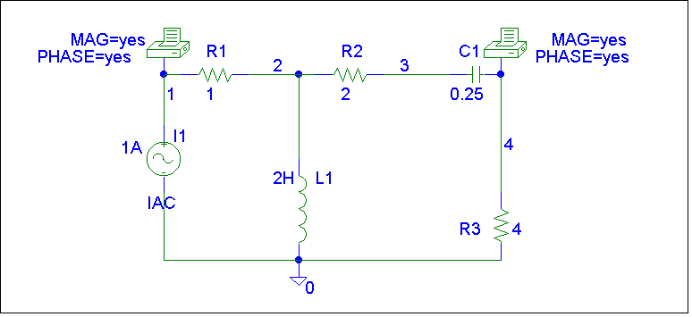
(b) In this case, we let I₂ = 1 A and open-circuit the input port. The schematic is shown below. In the AC Sweep box, we type Total Pts = 1, Start Freq = 0.3183, and End Freq = 0.3183. After simulation, the output file includes

FREQ VM(1) VP(1)

3.183 E–01 2.530 E+00 –1.084 E+02

FREQ VM(2) VP(2)

3.183 E–01 1.789 E+00 –1.534 E+02

From this,

z₁₂ = V₁/I₂ = 2.53∠–108.4°/1 = 2.53∠–108..4°

z₂₂ = V₂/I₂ = 1.789∠–153.4°/1 = 1.789∠–153.4°.

Thus,

[z] = Ω

